 | The Twenty-fourth Annual  Great Lakes Star Gaze  Sept. 10th to 13th, 2026  “A Star Party with Dark Skies”  Held at Ocqueoc Outdoor Center  in Millersburg, MI
GENERAL INFORMATION:
Dark Bortle 2 skies and convenient facilities are the main attractions of this star party. This is a star party for the astronomer who loves to observe and mingle with other astronomers. We will also have a tour of the night sky, swap meet and astronomy presentations!
GETTING TO OCQUEOC OUTDOOR CENTER:
7142 Ocqueoc Lake Road, Millersburg, MI 49759
Once on Ocqueoc Road follow the Brown Signs.
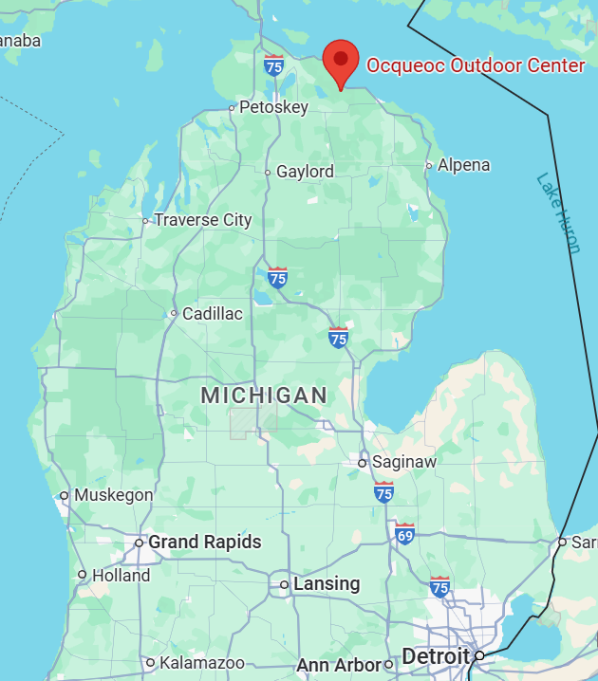
From I-75
Travel 26 miles East on M-68 from Exit 310.
Turn onto Ocqueoc Road, 7.6 miles North.
From M-33 heading North
Turn onto M-68 for 6.5 miles East.
Turn onto Ocqueoc Road, 7.6 miles North.
From US-23
Turn onto Town Hall Hwy, 0.4 miles West.
Turn onto Camp Road, 1.0 mile South.

WHAT IS INCLUDED WITH
REGISTRATION?
- Bunk houses sleeping facility (if chosen).
- Participation in observing and swap meet.
- Hot coffee/chocolate in dining area.
- Breakfast Saturday and Sunday 10:00 am.
- Clean, hot shower/restroom facilities.

NO Campers or RVs allowed at the site. No generators on site.
Telescope and equipment trailers are allowed.
We will have access to power in certain observing areas.
Multiple cabins, hotels, motels and campgrounds within 20 minutes around Black Lake and in Rogers City.

GREAT LAKES STAR GAZE 24 REGISTRATION FORM

To register by mail send this form to:

Nathan Spencer
P.O. Box 6
Akron, MI 48701

Phone: (989) 297-6617 e-mail: nathanspencer2@delta.edu

Make checks payable to: “Great Lakes Star Gaze”

Please Print Clearly:
Name:
Family members:
Phone Number:
E-mail:
Street:
City, State, Zip:
Emergency Contact Name:
Their Phone Number:
Their E-mail:

REGISTRATION: If you are not a family and you are sharing a tent with a friend you must each register separately as an individual. Families who wish to stay together must camp. If family members are staying in the bunkhouses you will need to pay for each as an individual. Multiply the amount by the number staying in the bunkhouses. Also note bunkhouse spaces are limited, once those are full only camping will be available. Since we have a limit on spaces there are no early bird discounts this year. Once you are registered there is no switching from bunkhouse to camping or camping to bunkhouse.

Included in this year’s registration is a continental breakfast both Saturday and Sunday. There will also be an optional meal on Saturday evening for the cost of $10, you can purchase this during the Star Gaze.

If registering as a family indicate number of persons (please list names above). | # = _____
Please state number of children under the age of 13 years. | # = _____

Individual Bunkhouse Registration Fee Friday/Saturday Nights | $90.00 | =$
Individual Bunkhouse Registration Fee Thursday/Friday/Saturday Nights | $120.00 | =$
Individual Camping Registration Fee Friday/Saturday Nights | $70.00 | =$
Individual Camping Registration Fee Thursday/Friday/Saturday Nights | $90.00 | =$
Family Camping Registration Fee Friday/Saturday Nights | $80.00 | =$
Family Camping Registration Fee Thursday/Friday/Saturday Nights | $120.00 | =$
To guarantee clothing form must be postmarked on or before August 17th.
Total Amount for Registration |  | $
Total Amount for Promotional Items (value below) |  | $
GRAND TOTAL ENCLOSED |  | $

For those staying in the bunkhouses. There will be both men’s and women’s sections of the bunkhouses. Please indicate the number of people and which section of the bunkhouse they are staying in.
Men’s Women’s
______ ______
GLSG²⁴ PROMOTIONAL ITEMS
Order now to guarantee your souvenir & price!
Please write in the quantity for each item in the box above the size.

Adult  Short Sleeve  T-shirt |  |  |  |  |  |  | $
Adult  Short Sleeve  T-shirt | S  $19.00 | M  $19.00 | L  $19.00 | XL  $19.00 | 2X  $22.00 | 3X  $22.00 | $
Adult  Long Sleeve  T-shirt |  |  |  |  |  |  | $
Adult  Long Sleeve  T-shirt | S  $22.00 | M  $22.00 | L  $22.00 | XL  $22.00 | 2X  $25.00 | 3X  $25.00 | $
TOTAL |  |  |  |  |  |  | $

Promotional items must be picked up at the star party. They will NOT be mailed! Clothing orders must be postmarked by August 17th. We have very little to no additional inventory this year for new clothing so if you wish to guarantee a t-shirt it must be pre-ordered.

Designs for 2026 GLSG²⁴

Short Sleeve T-shirt, Long Sleeve T-shirt: steel blue with multicolor design on the front. T-Shirts: 100% cotton, 5.3 oz, Gildan 5000®.

