|  |  |
| --- | --- |
|  | **The Twenty-third Annual**  **Great Lakes Star Gaze**  **Sept. 19th to 21st, 2025**  **“A Star Party with Dark Skies”**  **Held at Ocqueoc Outdoor Center**  **in Millersburg, MI** |

**GENERAL INFORMATION:**

Dark sky and facilities are the main attractions of this star party. This is a Bortle 2 sky. This is a star party for the astronomer who loves to observe and mingle with other astronomers. We will also have a tour of the night sky, swap meet, and a fishing contest (kids only) planned!

**GETTING TO OCQUEOC OUTDOOR CENTER:**

7142 Ocqueoc Lake Road, Millersburg, MI 49759

Once on Ocqueoc Road follow the Brown Signs.

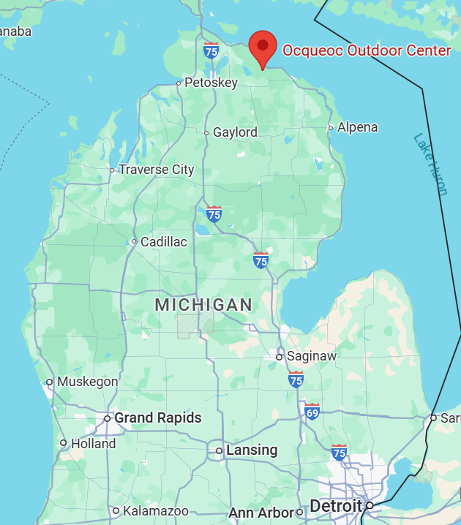**From I-75**

Travel 26 miles East on M-68 from Exit 310.

Turn onto Ocqueoc Road, 7.6 miles North.

**From M-33 heading North**

Turn onto M-68 for 6.5 miles East.

Turn onto Ocqueoc Road, 7.6 miles North.

**From US-23**

Turn onto Town Hall Hwy, 0.4 miles West.

Turn onto Camp Road, 1.0 mile South.

**WHAT IS INCLUDED WITH**

**REGISTRATION?**

* Bunk houses sleeping facility both nights.
* **Tent camping Saturday night only.**
* Participation in observing and swap meet.
* Hot coffee/chocolate in dining area.
* Dinner Saturday 5:00 pm and Breakfast Sunday 10:00 am.
* Clean hot shower/restroom facilities.

***NO* Campers or RVs allowed at the site. No generators on site.**

Telescope and equipment trailers are allowed.

We will have access to power in certain observing areas.

Multiple cabins, hotels, motels and campgrounds within 20 minutes around Black Lake and in Rogers City.

**GREAT LAKES STAR GAZE 23 REGISTRATION FORM**

To register by mail send this form to:

**Nathan Spencer, 1083 Valley Drive, Caro, MI 48724**

Phone: (989) 297-6617 e-mail: nathanspencer2@delta.edu

Make checks payable to: **“Great Lakes Star Gaze”**

Please Print Clearly:

|  |  |
| --- | --- |
| **Name:** |  |
| Family members: |  |
|  |  |
|  |  |
| **Phone Number:** |  |
| **E-mail:** |  |
| **Street:** |  |
| **City, State, Zip:** |  |
| **Emergency Contact Name:** |  |
| **Their Phone Number:** |  |
| **Their E-mail:** |  |

Following registration fees are per person. Either register for Friday/Saturday or just Saturday, not both. For example two adults registering for Friday and Saturday nights would put down X 2 and $100 in the top row. All registrations include dinner Saturday evening and breakfast Sunday morning.

|  |  |  |  |
| --- | --- | --- | --- |
| Registration Fee Friday/Saturday Nights | $50.00 | X_____ | =$ |
| Registration Fee Saturday Night | $25.00 | X_____ | =$ |
| Child (17 and under) Registration Fee Friday/Saturday Nights | $20.00 | X_____ | =$ |
| Child (17 and under) Registration Fee Saturday Night | $10.00 | X_____ | =$ |
| **Total Amount for Registration** |  |  | $ |
| **Total Amount for Promotional Items** |  |  | $ |
| **GRAND TOTAL ENCLOSED** |  |  | $ |

|  |  |
| --- | --- |
| Please state number of children under the age of 13 years. | # = _____ |

If you want to tent camp on Saturday please check this box.

**GLSG23 PROMOTIONAL ITEMS**

**Order now to guarantee your souvenir & price!**

Please write in the quantity for each item in the box above the size.

|  |  |  |  |  |  |  |  |
| --- | --- | --- | --- | --- | --- | --- | --- |
| **Adult**  **Short Sleeve**  T-shirt |  |  |  |  |  |  | $ |
| S  $17.00 | M  $17.00 | L  $17.00 | XL  $17.00 | 2X  $19.00 | 3X  $20.00 |
| **Adult**  **Long Sleeve**  T-shirt |  |  |  |  |  |  | $ |
| S  $25.00 | M  $25.00 | L  $25.00 | XL  $25.00 | 2X  $27.00 | 3X  $28.00 |
| **Adult**  **Hooded Sweatshirt** |  |  |  |  |  |  | $ |
| S  $34.00 | M  $34.00 | L  $34.00 | XL  $34.00 | 2X  $37.00 | 3X  $38.00 |
| **TOTAL** | | | | | | | $ |

Promotional items must be picked up at star party. They will NOT be mailed! Clothing orders must be postmarked **by August 25th.** After this date items may be purchased from extra stock at the star party. Sizes & quantities will be limited.

**Designs for 2025 GLSG23**

**Short Sleeve T-shirt, Long Sleeve T-shirt and Hooded Sweatshirt:** purple with multicolor design and logos on the front and logo on the sleeve in white. Short sleeve t-shirts: 100% cotton, 6.1 oz, Gildan - Softstyle® CVC. Long sleeve t-shirts: 100% cotton, 4.2 oz, Bella+Canvas®

**See images of all our apparel on next page.**

